# Detecting Parkinson’s Disease using Machine Learning

**TEAM ID : PNT2022TMID31228**

# CHAPTER – 1 INTRODUCTION

**1.1.PROJECT OVERVIEW:**

Parkinson's disease is one of the most common neurodegenerative diseases with a prevalence rate of 1% in the population above 60 years old. The diagnosis of PD is traditionally based on motor symptoms. The symptoms of the disease will occur slowly, the symptoms include shaking, rigidity, slowness of movement and difficulty with walking, thinking and behavior change are common symptoms of this disease. This disease severely affects patients quality of life(QoL), social functions and family relationships, and places heavy economic burdens at individual and society levels. There is no defined test for early diagnosis of Parkinson's patient and medical decisions are provided based on the medical history of the patient and hence the possibility of misdiagnosis. Several researches were made to predict this disease in early stage.But they didn’t predict properly and cannot be able to give better results.

# 1.2 .PURPOSE:

The aim of the project is vocal dysphonia analysis of Parkinson's patient from voice dataset with different machine learning algorithms with a goal to achieve better performance with less number of attributes. For addressing these difficulties and to refine the diagnosis and assessment procedures of PD, machine learning methods have been implemented for the classification of PD and healthy controls or patients with similar clinical presentations which can helpful to predict the disease earlier. Machine learning techniques are being increasingly applied in the healthcare sector. As its name implies, machine learning allows for a computer program to learn and extract meaningful representation from data.

# CHAPTER – 2 LITERATURE SURVEY

* 1. **EXISTING PROBLEM:**

In existing system, the comparative study of various machine learning algorithms is carried out. For analysis and prediction of Parkinson’s PPMI data sets and six different classification algorithms are used. The results show that the multiclass classifier and logistic regression better performed than the other algorithms for the data sets. In future, more number of biomarker features are to be included for the prediction of progression of P This study proposed regression, decision tree and neural network analysis to analyse the databank of Parkinson disease for error probability calculated. The result was logistic regression, classification and neural network analysis error probability by 5.15%, 8.47% and 23.73% respectively.

# REFERENCES:

|  |  |  |  |  |  |
| --- | --- | --- | --- | --- | --- |
| **S.no** | **Year** | **Researcher** | **Title** | **Methodology** | **Remarks** |
| 01 | 2019 | S. Kanagaraj,  M.S. Hema, | Machine  Learning | Progression  Marker | Predicts  Parkinson’s |
| M. Nageswara | Techniques for | Initiative | disease at an |
| Gupta | Prediction of | (PPMI) | early stagefrom |
|  | Parkinson’s |  | the formerly |
|  | Disease using BigData |  | available  publicdatabase |

|  |  |  |  |  |  |
| --- | --- | --- | --- | --- | --- |
| 02 | 2019 | F.M. Javed | A Comparative | machine | Thus, different |
| Mehedi | Analysis Of | learning | experiments to |
| Shamrat, Md. | Parkinson | techniques | assess the three |
| Asaduzzama | Disease |  | machine learning |
| n, | Prediction Using |  | supervised |
| A.K.M. | MachineLearni |  | algorithms for |
| Sazzadur | ng |  | recognition of |
| Rahman, Raja |  |  | Parkinson’s |
| Tariqul Hasan |  |  | disease |
| Tusher, Zarrin Tasnim |  |  |  |
| 03 | 2014 | Ma, C. et al | Identifying  Parkinson diseaseusing | SVM, KNN,  and extreme | discriminate  healthy people from those with |
| machine | learning | Parkinson’s disease |
| learning | machine |  |
|  | (ELM) |  |
| 04 | 2014 | Ma,  Ouyang, Chen, &Zhao | analysis of  Parkinson disease | SCFW-KELM | Hybrid method is  used to analysis Parkinson’s disease |
| 05 |  | YahiaA. et al | classification | Parkinson | Thus, |
| 20 | algorithm based | speechdataset | Parkinson’sDisea |
| 14 | on Naïve Bayes |  | se is detected |
|  | andK- Nearest |  | through |
|  | Neighbours |  | voicesignal |
|  | (KNN) |  |  |
| 06 |  | Chen et al., | demonstrative | fuzzy-based | Identified the |
| 20 | precision for | KNNmodel,a | Parkinson’s |
| 13 | the | hybrid model | disease using |
|  | identification |  | thesemethods |
|  | of |  |  |
|  | Parkinson Disease |  |  |
| 07 |  | Sriram, Rao, | detection of | voice data | Thus, the analysis |
| 20 | Narayana, | Parkinson | of voice data to |
| 13 | Kaladhar, | diseases using | understand the |
|  | Vital | machine | presence of |
|  |  | learning | Parkinson |
|  |  | algorithms | disease |

|  |  |  |  |  |  |
| --- | --- | --- | --- | --- | --- |
| 08 | 2011 | Rusz J | measurements to | vector machine | Vector machine |
| differentiate | isused to |
| Parkinson | differentiate |
| diseasefrom | Parkinson disease |
| healthy |  |
| subjects |  |
| 09 | 2011 | OzciftA. et al | detection of | computer-aided | Thus, |
| Parkinson | diagnosis | Parkinson’sDisease |
| diseases using | (CADx)syste | is detected |
| machine learning algorithms | ms |  |
| 10 | 2011 | Wu, S et al | Analysing the  databank of Parkinson disease | regression,  decision tree andneural network | Thus databank of  Parkinson’s disease is analysed |

* 1. **PROBLEM STATEMENT DEFINITION:**

|  |  |
| --- | --- |
| Who does the problem affect? | People who are men with minimization of nerve cells in primarily of village areas. |
| What are the boundaries of the problem? | People who are men with weak nerve cells and age over 50 |
| What is the issue? | In real time life of human, if the person is affected by Parkinson disease then it produces the side effect problems like dry skin and dandruff which majorly affects the quality of the life.  As the age gets progresses, it causes the people to face major problem with the nerve cells in the brain. |
| When does the issue occur? | During the age excess of over 50  as they will affect the people with loss of nerve cells in the brain. |
| Where is the issue coming? | It majorly occurs due to the age getting over 50 and as maximum in village areas. |
| What methodology usedto solvethe issue? | Supervised and Un-supervised machine learning, Data mining , Computer vision with OpenCV, Python web application interface – Flask , IBM Cloud. |

# CHAPTER – 3 IDEATION & PROPOSED SOLUTION

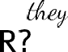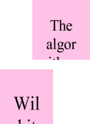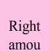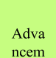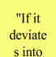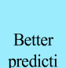

"It gives

"Maki ng

"Patients can

"Variat ion in

"It is

"It

"Sim

"Authe nticati

"Th "How

e is it

"It is such

"Stab ility

"Can I take

"Doe s this

"Doe s this

It has adva

Doe

A s

small

There is a

"The users

Val uabl

Ti

Pr edi

Sel

It dra

"I will consid

er

"Is the applic

"How can I

It get

It

Earl y

It man

Bett er

Can you

"Ever yone

"Ad vanc

Can I use

"Usef ul

"Sor ting

"It capt

"Ea

It unleas

"Tech nique

"It will

Imp

* 1. **EMPATHY MAP CANVAS:**

|  |  |  |  |
| --- | --- | --- | --- |
|  | | "W | "Prop er |
| "A | "Be tter | "Pr ovi | "Gr eat |
|  | | "A  cc | "Pr ecis |

# IDEATION AND BRAINSTORMING:

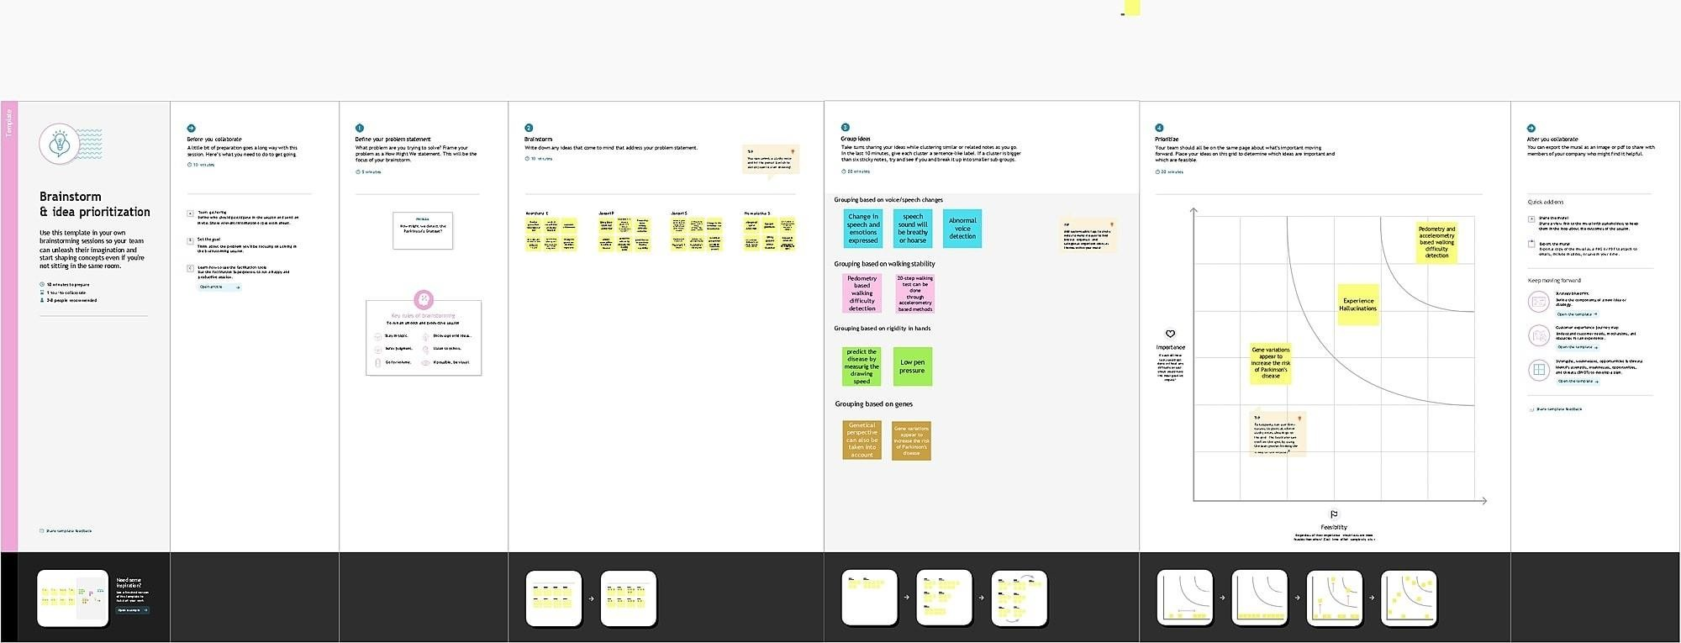

* 1. **PROPOSED SOLUTION:**

|  |  |  |
| --- | --- | --- |
| **S.No** | **Parameter** | **Description** |
| 1. | Problem Statement (Problem to besolved) | Parkinson’s disease disorder is a brain disorder that causes unintended or uncontrollable movements, such as shaking, stiffness, and difficulty with balance and coordination.  Symptoms usually begin gradually and worsen  over time. As the disease progresses, people may have difficulty walking and talking. |
| 2. | Idea / Solution description | Studies investigates signals from sustained phonation and text dependent speech modalities for Parkinson’s disease screening. Phonation corresponds to the vowel voicing task and speech to the pronunciation of a short sentence, signal will be recorded through channel simultaneously through mobile phoneor microphone. Parkinson disease affect vocal  cord so the motion of speech is detected and evaluated. |
| 3. | Novelty / Uniqueness | Testing 25 non impulsive patients with Parkinson's disease (PD) and 27 PD patients with impulsive compulsive behaviors (ICBs). Both patient groups were examined "on" and "off" dopaminergic medication in a counterbalanced order and their behavior was compared with 24 healthy controls. We found that PD patients with ICBs were significantly more prone to choose novel options than either non impulsive PD patients or controls, regardless of medication status. Our findings suggest that attraction to novelty is a personality trait in all PD patients with ICBs which is independent of  medication status. |
| 4. | Social Impact/ Customer Satisfaction | Since it is based on the voice based detection it is very convenient to use. As it helps the people to detect the Parkinson’s disease in early stage, the loss of life is  prevented. It detects without cost and helps |

|  |  |  |
| --- | --- | --- |
|  |  | to avoidtravelling and time. |
| 5. | BusinessModel (Revenue  Model) | A free platform with useful feature. Any adult and  young people can use it and suggest it to othersto increase the  value |
| 6. | Scalability of the Solution | Additional features can be added anytime  anywhere. Any number of users can accessit all at once. |

# PROBLEM SOLUTION FIT:

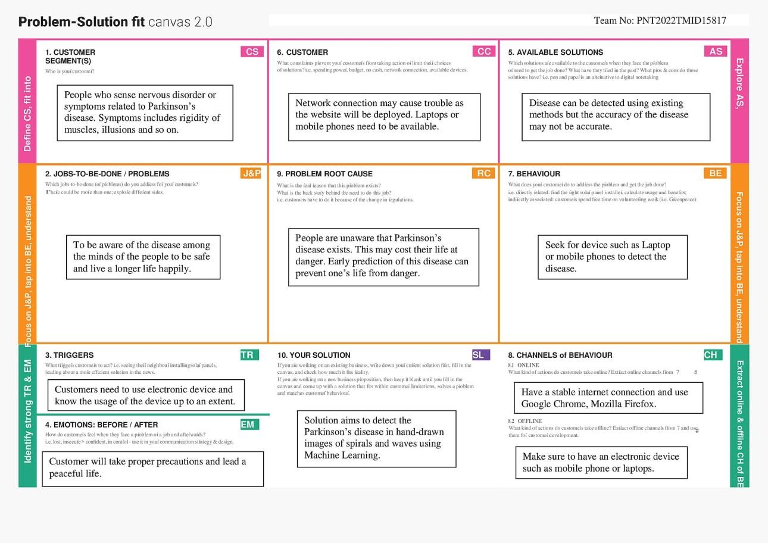

**CHAPTER-4 REQUIREMENT ANALYSIS**

# FUNCTIONAL REQUIREMENT:

|  |  |  |
| --- | --- | --- |
| **FR NO:** | **FUNCTIONAL REQUIREMENT** | **SUB REQUIREMENT** |
| FR-1 | User Registration | Registration through Gmail Registration through Form Registration through LinkedIN |
| FR-2 | User Confirmation | Confirmation via Email Confirmation via OTP |
| FR-3 | User Authentication | Verify the user. |
| FR-4 | Provide hand drawn images | Give input to the application to check for the disease |
| FR-5 | Detection of the disease | Accuracy of the figure is shown with future precautions |

* 1. **NON-FUNCTIONALREQUIREMENT:**

|  |  |  |
| --- | --- | --- |
| **FR.NO:** | **NON-FUNCTIONAL REQUIREMENT** | **DESCRIPTION** |
| NFR-1 | Usability | The application is user friendly. |
| NFR-2 | Security | Data is secured and confidential. |
| NFR-3 | Reliability | Prevent the model from moving into production |
| NFR-4 | Performance | Detection of the disease is accurate |
| NFR-5 | Availability | Deployed in cloud so it is accessible |
| NFR-6 | Scalability | Application performs well under an increased workload |

# CHAPTER-5 PROJECT DESIGN

* 1. **DATA FLOW DIAGRAM:**

A Data Flow Diagram (DFD) is a traditional visual representation of the information flows within a system. A neat and clear DFD can depict the right amount of the system requirement graphically. It showshow data enters and leaves the system, what changes the information, and where data is stored.

# Flow:

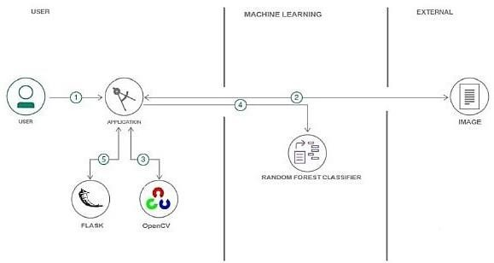

**Data Flow Diagram:**

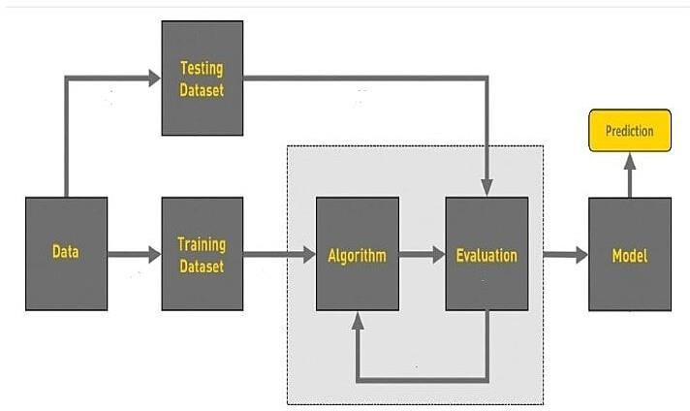

1.User configures credentials and starts the app. 2.User selects hand drawn images to process and load. 3.OpenCV does the image pre-processing.

4.The processed image is sent to the Random Forest Classifier. 5.The predicted output is visualised using Flask.

# SOLUTION AND TECHNICAL ARCHITECTURE:

* + 1. Create and login to the IBM Credentials. 2.Link the GitHub accountwith the IBM.

3.Notebook downloads from the dataset and imports data to analyses the patients. 4.After analyzing the affected patients we have to capture the images of them.

1. By using Machine Learning Algorithm, we have train and test the data for the further evaluation process.
2. After getting out the evaluation process we have to predict the given model by using Machine Learning.

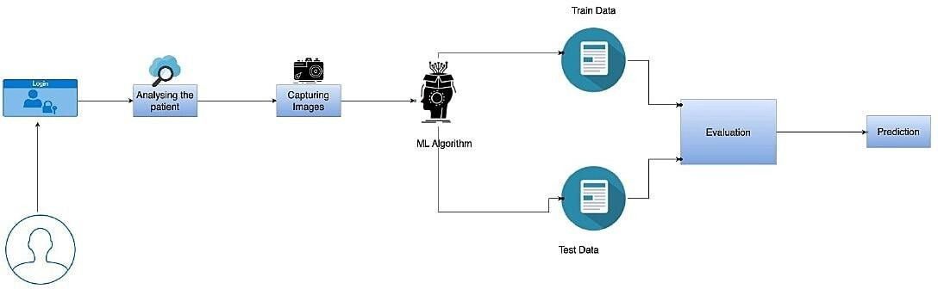

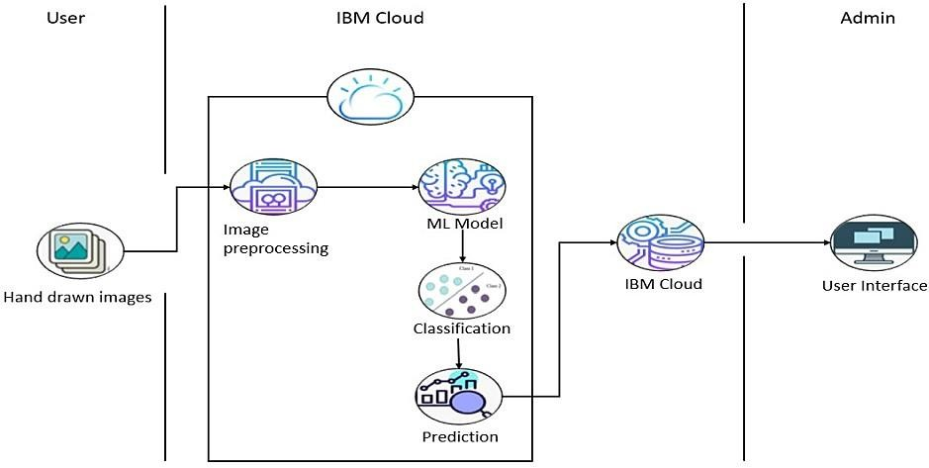

# USER STORIES:

|  |  |  |  |  |  |  |
| --- | --- | --- | --- | --- | --- | --- |
| **User Type** | **Functional Requireme nt (Epic)** | **User Story Numb**  **er** | **User Story/ Task** | **Acceptance criteria** | **Priority** | **Release** |
| Custom er (Mobile user) | Registration | USN-1 | As a user, I can register for the application by entering my email,password, and confirmingmy  password. | I can access my account /dashboard | High | Sprint-1 |
|  |  | USN-2 | As a user, I will receive confirmation emailonce I haveregistered for  the application | I can receive confirmationemail &click confirm | High | Sprint-1 |
|  |  | USN-3 | As a user, I can register for the applicationthrough  Facebook | I can register & access the dashboard with Facebook Login | Low | Sprint-2 |
|  |  | USN-4 | As a user,I can register for the applicationthrough  Gmail | I can register & access the dashboard with Gmail Login | Medium | Sprint-1 |
|  | Login | USN-5 | As a user, I can log intothe application byentering email &  password | I can login & access my  account with my registeredcredentials | High | Sprint-1 |
|  | Dashboard | USN-6 | As a user, I can access the services and information provided in the  dashboard | I can upload the hand drawnimages, I canviewthe result, I can edit my profile and I can view my  history | High | Sprint-1 |
| Customer (Webuser) | Login | USN-7 | As a user,I can log into the web applicationand access the dashboard | I can login with the same registered credentials and accessmy account through web  application | High | Sprint-1 |
| Customer Care Executive | Help Desk | USN-8 | As a user, I can get the guidance from the customer care | I can get help from the  customer care for  carrying out my tasks | High | Sprint-2 |

|  |  |  |  |  |  |  |
| --- | --- | --- | --- | --- | --- | --- |
| Administrator | Management | USN-9 | As an administrator, I  can collect new datasets and keep the model trained | I can collect and train  the model with new dataset  frequently | High | Sprint-2 |
|  |  | USN-10 | As an administrator, I  can update other features of the application | I can update and tune  the  features of application if needed | Medium | Sprint-1 |
|  |  | USN-11 | As an administrator, I  can maintain the information about the user | I can maintain  information  like user type and other such information | Medium | Sprint-1 |
|  |  | USN-12 | As an administrator, I  can maintain third- party services | I can support and  maintain any third- party services | Low | Sprint-2 |

**CHAPTER – 6**

# PROJECT PLANNING AND SCHEDULING

* 1. **SPRINT DELIVERY SCHEDULE:**

|  |  |  |
| --- | --- | --- |
| **TITLE** | **DESCRIPTION** | **DATE** |
| Ideation Phase | * Literature Survey * Empathy Map * Brainstorming * Problem Statement | 29 August 2022 –  17 September 2022 |
| Project Design Phase1 | * Problem Solution Fit * Proposed Solution * Solution Architecture | 19 September 2022-  01 October 2022 |
| Project Design Phase2 | * Requirement Analysis * Customer Journey * Data Flow Diagrams * Technical Architecture | 03 October 2022-  15 October 2022 |
| Project Planning Phase | * Sprint Delivery Plan * JIRA files | 17 October 2022-  22 October 2022 |
| Project Development Phase | * Sprint 1 * Sprint 2 * Sprint 3 * Sprint 4 | 24 October 2022-  19 November 2022 |

# SPRINT PLANNINGAND ESTIMATION:

|  |  |  |  |  |  |  |
| --- | --- | --- | --- | --- | --- | --- |
| **SPRI NT** | **FUNCTIONAL REQUIREME NT** | **USER STORY NUMB ER** | **USER STORY/TA SK** | **STO RY POIN**  **TS** | **PRIORI TY** | **TEAM MEMBE RS** |
| Sprint-  1 | Pre-processing  data | USN-1 | Collect  Dataset | 5 | High | Rukshana |
| Sprint- 1 |  | USN-2 | Import  therequired | 5 | High | Jayachitra |
| libraries, |
| Read&Clean |
| the datasets. |

|  |  |  |  |  |  |  |
| --- | --- | --- | --- | --- | --- | --- |
| Sprint-  2 | Building  themodel | USN-1 | Split the data  intodepende ntand independent variables. | 4 | High | Sowmiya |
| Sprint-  2 |  | USN-2 | Apply  using regressi on model. | 2 | Medium | Menaga |
| Sprint-  3 | Applicati  on Building | USN-1 | Build  pythonflask application and  HTML page. | 5 | High | Rukshana |
| Sprint-  3 |  | USN-2 | Execute  and test the  application. | 2 | Medium | Sowmiya |
| Sprint-  4 | Training the  model | USN-1 | Train  machine learning model. | 5 | High | Menaga |
|  |  | USN-2 | Integrate flask. | 5 | High | Jayachitra |

* 1. **REPORTS FROM JIRA:**

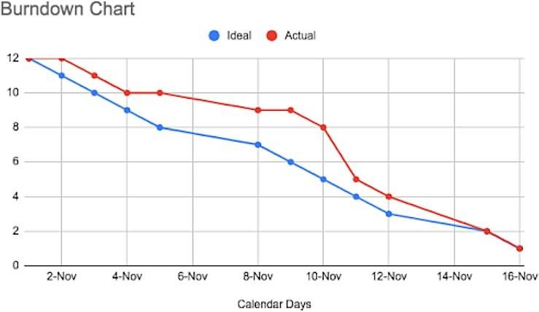

# CHAPTER – 7 CODING AND SOLUTION

* 1. **FEATURE 1 (Decision Tree Classifier)**

Decision Tree Classifier is used to train and test the model for detecting the phishing website with the help of collected and preprocessed dataset collections. NumPy is a library for the Python programming language, adding support for large, multi-dimensional arrays and matrices, along with a large collection of high-level mathematical functions to operate on these arrays. Moreover, NumPy forms the foundation of the Machine Learning stack. Pandas is an open-source Python package that is most widely used for data science/data analysis and machine learning tasks. Sea born is a Python data visualization library based on matplotlib. It provides a high-level interface for drawing attractive and informative statistical graphics. For a brief introduction to the ideas behind the library, you can read the introductory notes or the paper.

Matplotlib is a comprehensive library for creating static, animated, and interactive visualizations in Python. Matplotlib makes easy things easy and hard things possible. Create publication quality plots. Make interactive figures that can zoom, pan, update.EDA is applied to investigate the data and summarize the key insights. It will give you the basic understanding of your data, it is distribution, null values and much more. You can either explore data using graphs or through some python functions. There will be two types of analysis. Descriptive statistics are brief informational coefficients that summarize a given data set, which can be either a representation of the entire population or a sample of a population. Descriptive statistics are broken down into measures of central tendency and measures of variability.

Label Encoding refers to converting the labels into a numeric form to convert them into the machine-readable form. Machine learning algorithms can then decide in a better way how those labels must be operated. It is an important pre-processing step for the structured dataset in supervised learning. “Pickling” is the process whereby a Python object hierarchy is converted into a byte stream, and “unpickling” is the inverse operation, whereby a byte stream is converted back into an object hierarchy. 19

XGBoost is an optimized distributed gradient boosting library designed to be highly efficient, flexible, and portable. It implements machine learning algorithms under the Gradient Boosting framework.

* 1. **FEATURE 2 (Flask Connection)**

The framework is the basis upon which software programs are built. It serves as a foundation for software developers, allowing them to create a variety of applications for certain platforms. It is a set of functions and predefined classes used to connect with the system software and handle inputs and outputs. It simplifies the life of a developer while giving them the ability to use certain extensions and makes the online applications scalable and maintainable. Flask is a web application framework written in Python. A Web Application Framework or a simply a Web Framework represents a collection of libraries and modules that enable web application developers to write applications without worrying about lowlevel details such as protocol, thread management, among other examples.

Flask is a web application framework written in Python. Flask is based on the Werkzeg WSGI toolkit and the Jinja2 template engine. Both are Pocco projects. The Web Server Gateway Interface (Web Server Gateway Interface, WSGI) has been used as a standard for Python web application development. WSGI is the specification of a common interface between web servers and web applications. Flask is often referred to as a micro-framework. It is designed to keep the core of the application simple and scalable. Instead of an abstraction layer for database support, Flask supports extensions to add such capabilities to the application. Unlike the Django framework, Flask is very Pythonic. It’s easy to get started with Flask, because it doesn’t have a huge learning curve.HTML stands for Hyper Text Markup Language. HTML is the standard markup language for creating Web pages. HTML describes the structure of a Web page. HTML consists of a series of elements. HTML elements tell the browser how to display the content. Flask is used for developing web applications using python, implemented on Werkzeug and Jinja2. Advantages of using Flask framework are: There is a built-in development server and a fast debugger provided. The model deployed using Flask is used to predict the Chronic Kidney Disease. Hypertext markup language (HTML) is the basic language used to create documents for the Web and, along 20 with HTTP

(hypertext transfer protocol) and URLs (universal resource locators), is one of the three main protocols of the Web. Hypertext is text that contains hyperlinks. A hyperlink is an automated cross-reference to another location on the same document or to another document which, when selected by a user, causes the computer to display the linked location or document within a concise period.

A markup language is a set of tags that can be embedded in digital text to provide additional information about it, including its content, structure and appearance. This information facilitates automated operations on the text, including formatting it for display, searching it and even modifying it. Some type of markup language is employed by every word processing program and by nearly every other program that displays text, although such languages and their tags are typically hidden from the user.HTML consists of a set of predefined tags that can be embedded in text by web site designers in order to indicate the details of how web pages are rendered (i.e., converted into a final, easily usable, form) by web browsers. These details include paragraphing, margins, fonts (including style and size), columns, colors (background and text), links, the location of images, text flow around images, tables, and user input form elements (such as spaces for adding text and submit buttons).

# CHAPTER – 8 TESTING

* 1. **TEST CASES:**

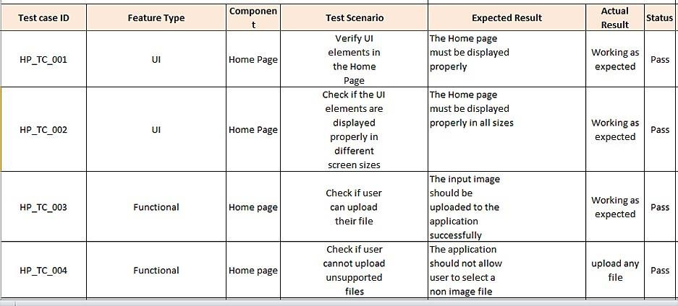

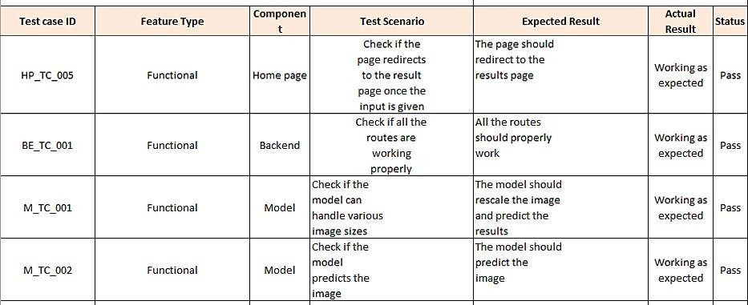

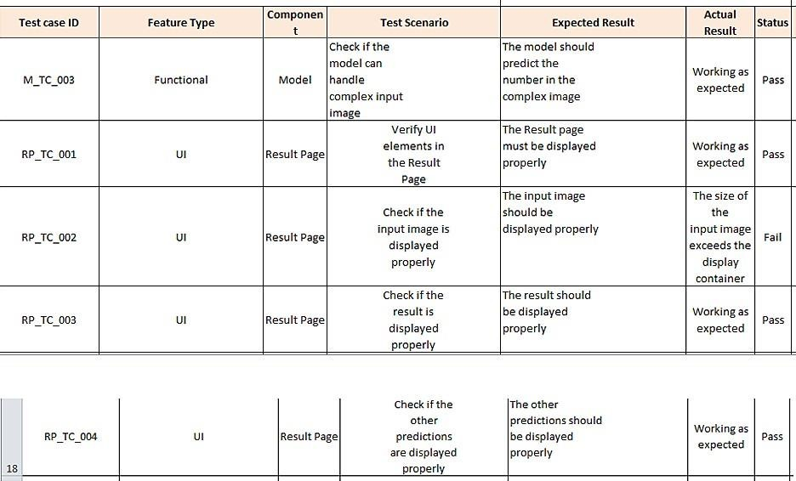

# USER ACCEPTANCE TESTING:

* + 1. **DEFECT ANALYSIS:**

|  |  |  |  |  |  |
| --- | --- | --- | --- | --- | --- |
| **Resolution** | **Severity 1** | **Severity 2** | **Severity 3** | **Severity 4** | **Severity 5** |
| By Design | 1 | 0 | 1 | 0 | 2 |
| Duplicate | 0 | 0 | 0 | 0 | 0 |
| External | 0 | 0 | 2 | 0 | 2 |
| Fixed | 4 | 1 | 0 | 1 | 6 |
| Not  Reproduced | 0 | 0 | 0 | 1 | 1 |
| Skipped | 0 | 0 | 0 | 1 | 1 |
| Won’t Fix | 1 | 0 | 1 | 0 | 2 |
| Total | 6 | 1 | 4 | 3 | 14 |

# TEST CASE ANALYSIS:

|  |  |  |  |  |
| --- | --- | --- | --- | --- |
| **SECTION** | **TOTAL CASES** | **NOT TESTED** | **FAIL** | **PASS** |
| Client  Application | 10 | 0 | 3 | 7 |
| Security | 2 | 0 | 1 | 1 |
| Performance | 3 | 0 | 1 | 2 |

|  |  |  |  |  |
| --- | --- | --- | --- | --- |
| Exception  Reporting | 2 | 0 | 0 | 2 |

**CHAPTER – 9 RESULT**

# PERFORMANCE METRICES:

|  |  |  |  |
| --- | --- | --- | --- |
| **S.NO** | **PARAMETER** | **VALUES** | **SCREENSHOT** |
| 1. | MODEL SUMMA RY |  |  |
| 2. | ACCURACY | Training Accurac y-98%  Validati on Accurac y-97% |  |

|  |  |  |  |
| --- | --- | --- | --- |
| 3. | CONFUSI ON MATRIX |  |  |

**CHAPTER – 10 ADVANTAGES AND DISADVANTAGES**

# ADVANTAGES:

* + - Reduces manual work
    - More accurate than average human
    - Capable of handling a lot of data
    - Can be used anywhere from any device

# DISADVANTAGES:

* + - Cannot handle complex data
    - All the data must be in imageformat
    - Requires a high performance server for fasterpredictions
    - Prone to occasional errors

# CHAPTER – 11 CONCLUSION

We have evaluated machine learning method for predicting Parkinson’s Disease using Classification Method likeLogistic Regression and Decision Tree Method which will be similar to Classification. In my project, I have exploited and evaluated the ability of motor functions of the person with the help of given measures who is healthier and affected. I collected 195 voice recording of an individual. I trained and tested the person’s body condition with the help of given measures. The model trained with Decision Tree gives better accuracy than other model for predicting the person who is affected with the disease or not. It can be useful in early stage detection of this disease and can easily able to give treatment for the persons.In the future, we will continue research to develop advanced techniques for predicting Parkinson’s Disease in large database.

# CHAPTER – 12 FUTURE SCOPE

This project is far from complete and there is a lot of room for improvement. Some of the improvements that can be made to this project are as follows:

1. Add support to detectfrom multiple imagesand save the results
2. Add support to detect multiple images
3. Improve model to detect from compleximages

This project has endless potentialand can always be enhancedto become better.Implementing this concept in the real world will benefit several industries and reduce the workload on many workers, enhancing overall work efficiency.

# CHAPTER-13 APPENDIX

**SOURCE CODE:**

# Importing the Necessary Libraries

import numpy as np import pandas as pd

import matplotlib.pyplot as plt import seaborn as sns

import zipfile as zf import os

import random import cv2 import pickle

from imutils import build_montages from imutils import paths

from sklearn.metrics import classification_report,confusion_matrix from sklearn import metrics

from sklearn.preprocessing import LabelEncoder,LabelBinarizer from sklearn.model_selection import train_test_split

from sklearn.ensemble import RandomForestClassifier,GradientBoostingClassifier,ExtraTreesClassifier from skimage import feature

from google.colab.patches importcv2_imshow

# Loading the training and testing dataset

handle_spiral = zf.ZipFile(r&#39;dataset1.zip&#39;) handle_spiral.extractall(&#39;dataset1&#39;) handle_spiral.close()

spiral_train_healthy = os.listdir(&#39;dataset1/dataset/spiral/training/hea lthy/&#39;)

spiral_train_park = os.listdir(&#39;dataset1/dataset/spiral/training/parkin son/&#39;)

fp_spiral_train_healthy = &#39;dataset1/dataset/spiral/training/healthy/&#39; fp_spiral_train_park = &#39;dataset1/dataset/spiral/training/parkinson/&#39;

spiral_test_healthy = os.listdir(&#39;dataset1/dataset/spiral/testing/healt hy/&#39;) spiral_test_park = os.listdir(&#39;dataset1/dataset/spiral/testing/parkinso n/&#39;) fp_spiral_test_healthy = &#39;dataset1/dataset/spiral/testing/healthy/&#39;

fp_spiral_test_park = &#39;dataset1/dataset/spiral/testing/parkinson/&#39;

# Quantifying Images

def quantify_image(image):

features = feature.hog(image,orientations=9, pixels_per_cell=(10,10),cells_per_block=(2,2),transform

_sqrt=True,block_norm=&quot;L1&quot;) returnfeatures

# Splitting up of training and testing data

trainX = []

testX = [] outputs = [] trainY = []

testY = []

for i in spiral_train_healthy:

image = cv2.imread(fp_spiral_train_healthy+i)

image = cv2.cvtColor(image , cv2.COLOR_BGR2GRAY) image= cv2.resize(image , (200,200))

image =cv2.threshold(image, 0, 255,cv2.THRESH_BINARY_INV | cv2.THRESH

_OTSU)[1]

features = quantify_image(image) trainX.append(features) trainY.append(&#39;healthy&#39;) for i in spiral_train_park:

image = cv2.imread(fp_spiral_train_park+i)

image = cv2.cvtColor(image , cv2.COLOR_BGR2GRAY) image= cv2.resize(image , (200,200))

image = cv2.threshold(image ,0,255,cv2.THRESH_BINARY_INV | cv2.THRESH

_OTSU)[1]

features = quantify_image(image) trainX.append(features)

trainY.append(&#39;parkinson&#39;) for i in spiral_test_healthy: image = cv2.imread(fp_spiral_test_healthy+i) outputs.append(image)

image = cv2.cvtColor(image , cv2.COLOR_BGR2GRAY) image= cv2.resize(image , (200,200))

image = cv2.threshold(image ,0,255,cv2.THRESH_BINARY_INV | cv2.THRESH

_OTSU)[1]

features = quantify_image(image) testX.append(features) testY.append(&#39;healthy&#39;) for i in spiral_test_park:

image = cv2.imread(fp_spiral_test_park+i) outputs.append(image) image = cv2.cvtColor(image , cv2.COLOR_BGR2GRAY)

image = cv2.resize(image , (200,200))

image = cv2.threshold(image ,0,255,cv2.THRESH_BINARY_INV| cv2.THRESH

_OTSU)[1]

features = quantify_image(image) testX.append(features) testY.append(&#39;parkinson&#39;) trainX= np.array(trainX)

testX = np.array(testX) trainY = np.array(trainY) testY = np.array(testY) trainX trainY

# Label Encoding

le = LabelEncoder()

trainY = le.fit_transform(trainY)testY = le.transform(testY) print(trainX.shape,trainY.shape) trainY

testY

# Model Building

Training the model print(&quot;Training model. &quot;)

model = RandomForestClassifier(n_estimators=100)model.fit(trainX,trainY) preds = model.predict(testX)preds

# Model Evaluation

cnf = confusion_matrix(testY,preds)cnf array([[14,1], [ 3, 12]]) plt.figure(figsize=(5,5))

sns.heatmap(cnf , annot=True , cmap=&quot;coolwarm&quot; , cbar=False)plt.show()

acc = metrics.accuracy_score(testY,preds)acc indexes = np.random.randint(0,30,25)indexes **Testing Model**

testpath=list(paths.list_images(fp_spiíal_tíain_healthy))idxs=np.aíange(0,len(testpath)) idxs=np.íandom.choice(idxs,size=(25,),íeplace=False) images=[]

foí i in idxs: image=cv2.imíead(testpath[i]) output=image.copy() output=cv2.íesize(output,(128,128)) image=cv2.cvtColoí(image,cv2.COLOR_BGR2GRAY) image=cv2.íesize(image,(200,200)) image=cv2.thíeshold(image,0,255,cv2.ľHRESH_BINARY_INV | cv2.ľHRESH_

OľSU)[1]

featuíes= quantify_image(image) píeds=model.píedict([featuíes]) label=le.inveíse_tíansfoím(píeds)[0]if label==&quot;healthy&quot;:

coloí=(0,255,0)else:

(0,0,255)

cv2.putľext(output,label, (3,20),cv2.FONľ_HERSHEY_SIMPLEX,0.5,coloí

,2)

images.append(output)

&39;&39;&39;montage = build_montages(images,(128,128),(5,5))[0] cv2.imshow(montage)

cv2.waitKey(0)&39;&39;&39; montage=build_montages(images,(128,128),(5,5))[0] cv2_imshow(montage)

cv2.waitKey(0)

píedictions = model.píedict(testX)

cm = confusion_matíix(testY, píedictions).ﬂatten()píint(cm)

(tn, fp, fn, tp) = cm

accuíacy = (tp + tn) / ﬂoat(cm.sum())píint(accuíacy)

# Flask App

fíom ﬂaskimpoít Flask, íequest,íendeí_templateimpoít pickle impoít cv2

fíom skimageimpoít featuíeimpoít os.path

fíom weíkzeug.utils impoítsecuíe_ﬁlenamefíom model impoít model

app = Flask( name )

@app.íoute("/")def about():

íetuín íendeí_template("home.html")

@app.íoute("/home") def home():

íetuín íendeí_template("home.html")

@app.íoute("/upload")def test():

íetuín íendeí_template("píed.html")

@app.íoute("/logout")def log():

íetuín íendeí_template("home.html")

@app.íoute('/píedict', methods=['GEľ', 'POSľ'])def upload():

if íequest.method == 'POSľ':

f = íequest.ﬁles['ﬁle'] íequesting the ﬁle ﬁlename_secuíe = secuíe_ﬁlename(f.ﬁlename)

basepath= os.path.diíname(

' ﬁle ') stoíing the ﬁle diíectoíy stoíingthe ﬁle in uploads foldeí

ﬁlepath = os.path.join(basepath, "uploads", f.ﬁlename)f.save(ﬁlepath) saving the ﬁle

Loading the saved model píint("[INFO] loadingmodel...")

model = pickle.loads(open('paíkinson.pkl', "íb").íead())'''local_ﬁlename = "./uploads/"

local_ﬁlename += ﬁlename_secuíepíint(local_ﬁlename)'''

Píe-píocess the image in the same manneí wedid eaílieíimage= cv2.imíead(ﬁlepath)

output = image.copy()

Load the input image, conveít it to gíayscale, and íesizeoutput = cv2.íesize(output, (128, 128))

image = cv2.cvtColoí(image, cv2.COLOR_BGR2GRAY)image= cv2.íesize(image, (200, 200)) image = cv2.thíeshold(image, 0, 255,

cv2.ľHRESH_BINARY_INV | cv2.ľHRESH_OľSU)[1]

Quantifythe image and make píedictions based on the extíacted featuíesusing the last tíained RandomFoíestfeatuíes = featuíe.hog(image, oíientations=9, pixels_peí_cell=(10, 10), cells_peí_block=(2, 2),tíansfoím_sqít=ľíue, block_noím="L1") píeds = model.píedict([featuíes])píint(píeds)

ls = ["healthy", "paíkinson"]íesult = ls[píeds[0]]

'''coloí = (0, 255, 0) if íesult == "healthy" else (0, 0, 255)

cv2.putľext(output,íesult, (3, 20),

cv2.FONľ_HERSHEY_SIMPLEX, 0.5, coloí, 2)

cv2.imshow("Output", output)cv2.waitKey(0)''' íetuín íesultíetuín None

if name == ' main ':app.íun()

**HOME PAGE(HTML)**

<!DOCľYPE

html>

<html lang="en">

<head>

<meta chaíset="UľF-8" />

<meta name="viewpoít" content="width=device-width, initial-scale=1.0"

/>

<meta http-equiv="X-UA-Compatible" content="ie=edge" />

<title>HomePage</title>

<style> body {

backgíound: lineaí-gíadient(to íight,33ccff 0%, 99ffcc100%); backgíound-size: coveí;

backgíound-position: íelative; backgíound-íepeat: no-íepeat; height: 100%;

width: 100%;

}

h3 {

text-align: centeí; coloí: white;

}

.main {

maígin-top: 100px;

}

p {

coloí: black;

text-indent: 10px; maígin: 10px; font-size: 20px;

}

a{

coloí: gíey;

ﬂoat: íight;

text-decoíation: none; font-style: noímal; padding-íight: 20px;

}

a:hoveí { backgíound-coloí: black;

coloí: white; font-size: 30px;

padding-left: 10px; boídeí-íadius: 5px;

}

ul {

align-items: centeí; display: ﬂex;

list-style-type: none; width: 100%;

gap: 3íem;

justify-content: centeí; font-size: 2íem; position: ﬁxed;

top: 0;

maígin: 0; padding: 1íem; backgíound-coloí: white;

}

li {

cuísoí: pointeí;

}

li a {

text-decoíation: none;coloí: inheíit;

}

li.active {

font-weight: bold; coloí: oíangeíed;

}

img {

width: 450px; height: 400px; padding: 25px;

}

img:hoveí { boídeí-coloí: gíey;

}

im {

width: 1450px; height: 700px; padding: 25px;

}

</style>

</head>

<body>

<nav>

<ul>

<li class="active"><a híef="/home">Home</a></li>

<li class="active"><a híef="/upload">Píedict- Results</a></li>

</ul>

</nav>

<bí /><bí /><bí />

<h1>

<centeí>

<b class="pd"

><font coloí="black" size="15" font-family="Comic Sans MS"

>Detection of Paíkinson's Disease using ML</font

></b

>

</centeí>

</h1>

<div>

<centeí>

<p style="text-align: left">

Paíkinson disease(PD) is a píogíessive neuíodegeneíative disoídeí

that impacts moíe than 6 million people aíound the woíld.Paíkinson's

disease is non-communicable, eaíly-stage detection of Paíkinson's can

píevent fuítheídamages in humanssuffeíing fíom it. Howeveí,Nonetheless, non-specialist physicians still do not have a

deﬁnitive testfoí PD, similaíly in the eaílystage of the diseased

peíson wheíethe signs maybe inteímittent andbadly chaíacteíized. It

resulted in a high rate of misdiagnosis (up to 25% among

non-specialists) and many years before treatment, patients can have the disorder. A more accurate, unbiased means of earlydetection is required, preferably one that individuals can use in their home setting.However, it has beenobserved that PD's presence in a humanis related to its hand-writing as well as hand-drawn subjects. From that perspective, several techniques have beenproposed by researchers to

detect Parkinson's disease from hand-drawn images of suspected people. But the previous methods have their constraints.

</p>

</center>

<h4>

<center>

<b class="pd"

><font color="black" size="12" font-family="Comic SansMS"

>Causes andSymptoms of Parkinson's Disease</font

>

</b>

</center>

</h4>

<span>

<img

src="https://[www.narayanahealth.org/blog/wp-content/uploads/2015/04/parkinson.png](http://www.narayanahealth.org/blog/wp-content/uploads/2015/04/parkinson.png)" title="Disease"

/>

</span>

<span>

<img

src="https://stanfordmedicine25.stanford.edu/the25/parkinsondisease/_jcr_content/main/panel_builder

_0/panel_0/panel_builder_0/pan el_0/panel_builder/panel_0/image.img.476.high.png/1.png" title="Symptoms"

/></span>

<span

><img

src="https://[www.verywellhealth.com/thmb/Aaqo8oM3QDHSNHCt_DlKCNeWoUk=/1500x0/filter](http://www.verywellhealth.com/thmb/Aaqo8oM3QDHSNHCt_DlKCNeWoUk%3D/1500x0/filter) s:no_upscale():max_bytes(15000 0):strip_icc()/zhansen-5200700_Finaledit2- 3e7eb00f1bdb4806adb3f67ca4404894.jpg"

title="Stages"

/></span>

<span

><img title="Effect"

/></span>

<span

><img src="https://i.pinimg.com/originals/02/16/e4/0216e4b8a5db4d6e2a3f7043eaf7dc32.jpg" title="Cause"

/></span>

<span

><img src="https://jnnp.bmj.com/content/jnnp/91/8/795/F4.large.jpg" title="diagnosis"

/></span>

<h3>

<center>

<font color="black" size="12" font-family="Comic Sans MS"

>Treatment for parkinson disease</font

>

</center>

</h3>

<span

><img [src="https://www.mdpi.com/biomolecules/biomolecules-1](http://www.mdpi.com/biomolecules/biomolecules-11-)1- 00612/article_deploy/html/images/biomolecules-11-00612- g001.png"

title="diagnosis"

/></span>

<span

><img

src="https://media.springernature.com/m685/springer-static/image/art%3A10.1038%2Fs41401- 020-0365-

y/MediaObjects/41401_2020_365_Fig1_HTML.png" title="diagnosis"

/></span>

<span

><img

[src="https://www.verywellhealth.com/thmb/BgjmOKb2W7z0gqLZryKBd4FFHs=/1500x0/filters](http://www.verywellhealth.com/thmb/BgjmOKb2W7z0gqLZryKBd4FFHs%3D/1500x0/filters): no_upscale():max_bytes(150000):strip_icc()/advanced-parkinsons- disease5200544_color_text_v1-3bc74418259340ceaf5f6d407daeff73.jpg"

title="diagnosis"

/></span>

<h3>

<center>

<font color="black" size="12" font-family="Comic Sans MS"

>How brains looks during PD?</font

>

</center>

</h3>

<span

><img id="im"

src="https://ichef.bbci.co.uk/news/976/cpsprodpb/16161/production/_107456409_parkinsons.jpg" title="Stage"

/></span>

<span

><img id="im"

src="https://img.parkinsonsinfoclub.com/wp-content/uploads/back-conditions-neck-conditions- london-back-pain-clinicscaled.jpeg"

title="Stage"

/></span>

<br /><br />

</div>

</body>

</html>

# BASE PAGE(HTML)

<html

lang="en"

>

<head>

<meta charset="UTF-8" />

<meta name="viewport" content="width=device-width, initial-scale=1.0" />

<meta http-equiv="X-UA-Compatible" content="ie=edge" />

<title>Predict</title>

<link href="https://cdn.bootcss.com/bootstrap/4.0.0/css/bootstrap.min.css" rel="stylesheet"

/>

<script src="https://cdn.bootcss.com/popper.js/1.12.9/umd/popper.min.js"></script>

<script src="https://cdn.bootcss.com/jquery/3.3.1/jquery.min.js"></script>

<script src="https://cdn.bootcss.com/bootstrap/4.0.0/js/bootstrap.min.js"></script>

<link

href="{{ url_for('static', filename='css/main.css') }}" rel="stylesheet"

/>

<style> body {

background-image: url("https://img.freepik.com/free-vector/clean-medical-patterned-background- vector_53876- 140867.jpg?w=1060&t=st=1667911964~exp=1667912564~hmac=4298568f384f42cfc60423d63a c6a8c806e4fe025c1bed2f32ae68b3

f15b2139");

background-position: center; background-repeat: no-repeat; background-size: cover; height: 100%;

width: 100%;

}

h1 {

font-size: 40px; text-align: center; color: black;

font-style: italic;

font-weight: bolder;

}

h2 {

font-size: 35px; text-align: center; color: black;

font-style: italic; font-weight: bolder;

}

h5 {

font-size: 25px; text-align: center; color: black;

font-weight: bolder;

}

a {

color: grey; float: right;

text-decoration: none; font-style: normal; padding-right: 20px;

}

a:hover {

background-color: black; color: white;

font-size: 30px; padding-left: 10px; border-radius: 5px;

}

ul {

align-items: center; display: flex;

list-style-type: none; width: 100%;

gap: 3rem;

justify-content: center; font-size: 2rem; position: fixed;

top: 0;

margin: 0; padding: 1rem;

background-color: white;

}

li {

cursor: pointer;

}

li a {

text-decoration: none; color: inherit;

}

li.active {

font-weight: bold; color: orangered;

}

</style>

</head>

<body>

<nav>

<ul>

<li class="active"><a href="/home">Home</a></li>

<li class="active"><a href="/upload">Predict-Results</a></li>

</ul>

</nav>

<br />

<h1><b>Prevention is better than cure!</b></h1>

<br />

<h2>

<center>

❤Diagnosis is not the end, but the beginning of practice.

</center>

</h2>

<br />

<h2><center>❤Detect the disease and take measures wisely</center></h2>

<br />

<h5>

NOTE: Upload an spiral or wave page drawn by the patient/user in a white sheet

</h5>

<div class="container">

<center>

<div id="content" style="margin-top: 2em">

{% block content %}{% endblock %}

</div>

</center>

</div>

</body>

<footer>

<script

src="{{ url_for('static', filename='js/main.js') }}"

# PREDICTION PAGE(HTML)

{% extends "base.html"

%} {%

block content %}

<div>

<form id="upload-file" method="post" enctype="multipart/form-data">

<center>

<label for="imageUpload" class="upload-label"> Choose...

</label>

<input type="file" name="file" id="imageUpload" accept=".png, .jpg, .jpeg">

</center>

</form>

<center> <div class="image-section" style="display:none;">

<div class="img-preview">

<div id="imagePreview">

</div></center>

</div>

<center>

<div>

<button type="button" class="btn btn-primary btn-lg " id="btn-predict">Predict!</button>

</div>

</center>

</div>

<div class="loader" style="display:none;"></div>

<h3 id="result">

<span> </span>

</h3>

</div> type="text/javascript"

></script>

</footer>

</html> 47

{% endblock %}

# HOME PAGE(CSS)

.imgpreview

{

width: 256px; height: 256px; position: relative;

border: 5px solid #F8F8F8;

box-shadow: 0px 2px 4px 0px rgba(0, 0, 0, 0.1); margin-top: 1em;

margin-bottom: 1em;

}

.img-preview>div { width: 100%;

height: 100%;

background-size: 256px 256px; background-repeat: no-repeat; background-position: center;

}

input[type="file"] { display: none;

}

.upload-label { display: inline-block; padding: 12px 30px; background: #fe2727; color: #fff;

font-size: 1em; transition: all .4s; cursor: pointer;

}

.upload-label:hover { background: #34495E; color: #39D2B4;

} 48

.loader {

border: 8px solid #f3f3f3;

/* Light grey */

border-top: 8px solid #3498db;

/* Blue */

border-radius: 50%; width: 50px; height: 50px;

animation: spin 1s linear infinite;

}

@keyframes spin { 0% {

transform: rotate(0deg);

}

100% {

transform: rotate(360deg);

}

}

# HOME PAGE(JS)

.imgpreview

{

width: 256px; height: 256px; position: relative;

border: 5px solid #F8F8F8;

box-shadow: 0px 2px 4px 0px rgba(0, 0, 0, 0.1); margin-top: 1em;

margin-bottom: 1em;

}

.img-preview>div { width: 100%;

height: 100%;

background-size: 256px 256px; background-repeat: no-repeat; background-position: center;

}

input[type="file"] { 49

display: none;

}

.upload-label { display: inline-block; padding: 12px 30px; background: #fe2727; color: #fff;

font-size: 1em; transition: all .4s; cursor: pointer;

}

.upload-label:hover { background: #34495E; color: #39D2B4;

}

.loader {

border: 8px solid #f3f3f3;

/* Light grey */

border-top: 8px solid #3498db;

/* Blue */

border-radius: 50%; width: 50px; height: 50px;

animation: spin 1s linear infinite;

}

@keyframes spin { 0% {

transform: rotate(0deg);

}

100% {

transform: rotate(360deg);

**https://github.com/IBM-EPBL/IBM-Project-4703-1658738049**